81%
This hands-on test is an individual assessment meaning you may not get assistance from your instructor or other classmates. You may use your textbook, labs and lecture notes.
All code submitted must be your original work. Code must be committed and pushed to your git repository inside the HOT1 folder to receive credit. No partial credit on any points.

Implement both exercises in one Visual Studio project with links between 2 pages. -10pts

HomeController and Layout file are optional for this test only.

DistanceConverter
Write a program that converts distances between inches and centimeters.
- Prompt the user for a distance in inches.
- When the user submits the form, display the distance in both inches and centimeters as follows:
“2.00 inches is 5.08 centimeters”
- See rubric on next page for more details.

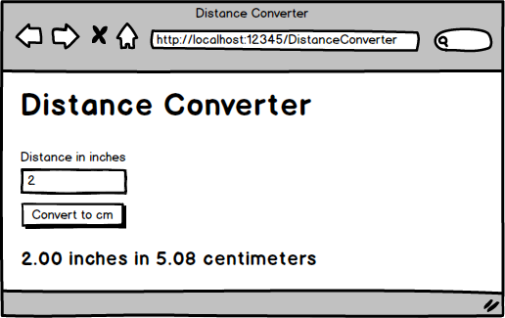

DistanceConverter - Rubric [40 pts]
- Model created and used _____
  - Distance should be a required field, with a custom validation message, that must be between 1 and 500 - 5pts
  - Error Messages in the view display the custom validation message as defined in the model - 5pts
- Controller created and implemented _____
  - [HttpGet] and [HttpPost] attributes applied to action methods -2pts
  - POST action method checks if the model is valid before performing conversions - 2pts
  - POST action method performs the conversion correctly - 5pts
- View laid out as shown in the mockup _____
  - Title - 2pts
  - Labels, Inputs, and Button - 1pt
  - Inches and Centimeters are formatted with two decimal places in the View - 2pts
- Bootstrap used to style the page _____ / 2pts each
  - Implement the latest version of Bootstrap
  - Bootstrap stylesheet included via libman
  - A collapsible Bootstrap Navbar
  - Floating labels to associate the textbox with the label controls
  - form-control class applied to input boxes
  - text-danger class applied to error messages
  - btn and btn-primary classes applied to button
  - margins applied to make the form look professional

OrderForm
Create a program for ordering T-Shirts.
- Users must enter a quantity.
- Users can enter an optional discount code.
- Shirts are normally $15 each. Sales tax is 8%.
- If the discount code is valid, then apply the relevant discount.
- If the discount code is not valid, then display an error message and calculate the receipt without a discount
- See rubric on next page for more details.

Discount Code | Discount Percentage
6175 | 30% off
1390 | 20% off
BB88 | 10% off

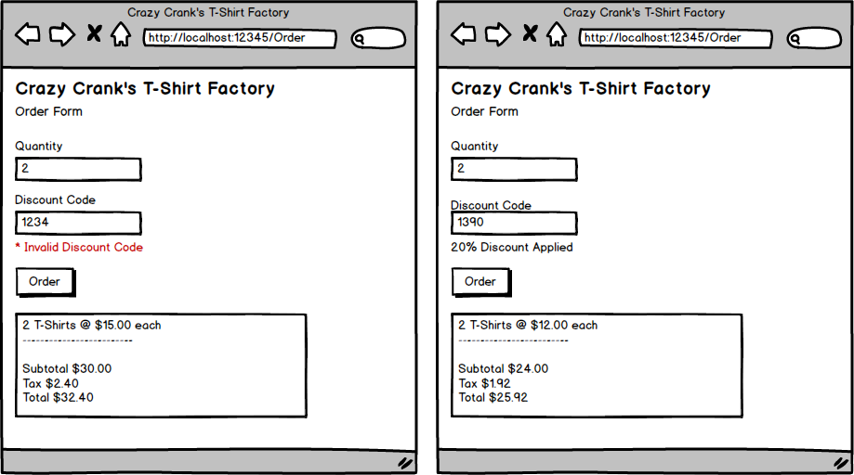

OrderForm - Rubric [50 pts]
- Model class created and used _____
  - Quantity is required and a custom error message - 5pts
  - Error Messages in the view display the custom validation message as defined in the model - 5pts
- Controller class created and implemented _____
  - Calculates the subtotal, tax, and total correctly -5pts
  - Applies a valid discount code correctly to the shirt cost -5pts
  - Calculates the subtotal, tax, and total correctly even if a valid discount code is not provided - 5pts
- View laid out as shown in the mockup _____
  - Error Messages in red and only displayed when appropriate - 5pts
  - Monetary amounts are formatted as currency - 2pts
- Bootstrap used to style the page _____ / 2pts each
  - Implement the latest version of Bootstrap
  - Bootstrap stylesheet included via libman
  - A collapsible Bootstrap Navbar
  - Floating labels to associate the textbox with the label controls
  - form-control class applied to input boxes
  - text-danger class applied to error messages
  - btn and btn-primary classes applied to button
  - margins applied to make the form look professional

